SystemVerilog - Оператори

Оператори
SystemVerilog assignment operators
Пример - логически оператори
Пример - аритметични оператори
Пример - условен оператор
Оператор if-else-if
Оператор case
Пример alu.sv

Оператори
побитови  ~ НЕ  & И  | ИЛИ  ^ XOR  ~^ XNOR | логически  ! логическо НЕ  && логическо И  || логическо ИЛИ | релации  < по-малко  <= по-малко или равно  > по-голямо  >= по-голямо или равно  == равно  != неравно  === равно (вкл. X и Z)  !== неравно (вкл. X и Z)
аритметични  + събиране  - изваждане  * умножение  / деление  % остатък | други  { } конкатенация  << преместване в ляво  >> преместване в дясно  ?: условен оператор

SystemVerilog assignment operators
Continuous assignment (nets and variables)
assign net_lvalue = expression

example
assign mynet = enable;

Procedural assignments (variables)
Blocking
variable_lvalue assignment_operator expression
assignment_operator: = | += | -= | *= | /= | %= | &= | |= | ^= | <<= | >>= | <<<= | >>>=

= assign right-hand side to left-hand side
+= add right-hand side to left-hand side and assign
-= subtract right-hand side from left-hand side and assign
*= multiply left-hand side by right-hand side and assign
/= divide left-hand side by right-hand side and assign
%= divide left-hand side by right-hand side and assign the remainder
&= bitwise AND right-hand side with left-hand side and assign
|= bitwise OR right-hand side with left-hand side and assign
^= bitwise exclusive OR right-hand side with left-hand side and assign
<<= bitwise left-shift the left-hand side by the number of times indicated by the right-hand side and assign
>>= bitwise right-shift the left-hand side by the number of times indicated by the right-hand side and assign
<<<= arithmetic left-shift the left-hand side by the number of times indicated by the right-hand side and assign
>>>= arithmetic right-shift the left-hand side by the number of times indicated by the right-hand side and assign
Nonblocking
variable_lvalue <= expression

Пример - побитови оператори | логически оператори
module bitwise_operators(  input [3:0] A, B,  output [3:0] A_or_B, A_and_B, not_A  );  assign A_or_B = A | B;  assign A_and_B = A & B;  assign not_A = ~A;  endmodule | module logical_operators(  input [3:0] A, B,  output [3:0] A_or_B, A_and_B, not_A  );  assign A_or_B = A || B;  assign A_and_B = A && B;  assign not_A = !A;  endmodule
A B -> A_or_B A_and_B not_A  0000 0000 -> 0000 0000 1111  1111 0000 -> 1111 0000 0000  0001 0001 -> 0001 0001 1110  1010 0101 -> 1111 0000 0101 | A B -> A_or_B A_and_B not_A  0000 0000 -> 0000 0000 0001  1111 0000 -> 0001 0000 0000  0001 0001 -> 0001 0001 0000  1010 0101 -> 0001 0001 0000
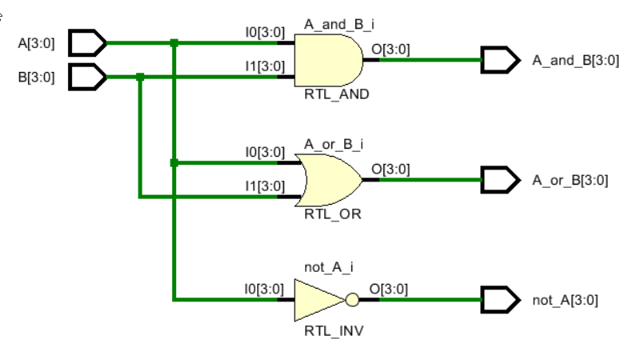 | 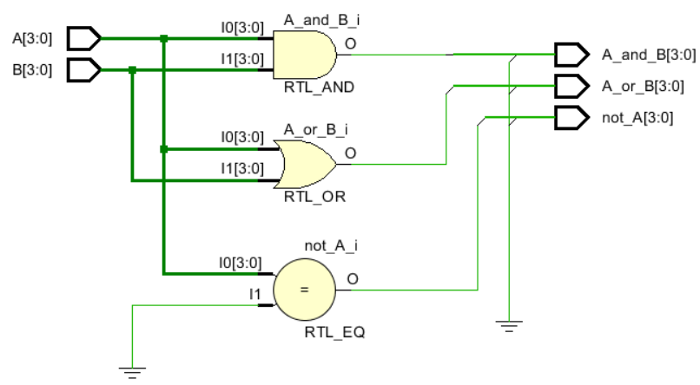

Пример - релации
module comparator (
output A_lt_B, A_eq_B, A_gt_B,
input [3:0] A, B
);

assign A_lt_B = A < B;
assign A_gt_B = A > B;
assign A_eq_B = A == B;
endmodule

Пример - аритметични оператори

module adder_4b(
output [3:0] Sum,
output C_out,
input [3:0] A, B,
input C_in
);

assign {C_out, Sum} = A + B + C_in;
endmodule

Пример - условен оператор
examples/simulation/mux_2x1.sv
module mux_2x1_cont(
output logic [7:0] y,
input [7:0] a,b,
input select);

assign y = select ? a : b;
endmodule

Оператор if-else-if
if (израз 1) оператор 1
else if (израз 2) оператор 2
… още else if …
else оператор 3

Пример
examples/simulation/mux_2x1.sv

module mux_2x1_proc(
output logic [7:0] y,
input [7:0] a,b,
input select);

always_comb
if (select) y = a;
else y = b;
endmodule

Пример
if (alu_func == 2’b00) aluout = a + b;
else if (alu_func == 2’b01) aluout = a - b;
else if (alu_func == 2’b10) aluout = a & b;
else aluout = a | b;

Оператор case
case (израз)
избор 1: оператор 1
избор 2: оператор 2
… още case …
default: оператор 3
endcase

Пример alu.sv
examples/simulation/alu_definitions.sv
package definitions;
typedef enum logic [2:0] {ADD,SUB,MULT,DIV,SL,SR} opcode_t;
typedef enum logic {UNSIGNED, SIGNED} operand_type_t;
typedef union packed {
logic [23:0] u_data;
logic signed [23:0] s_data;
} data_t;
typedef struct packed {
opcode_t opc;
operand_type_t op_type;
data_t op_a;
data_t op_b;
} instruction_t;
endpackage

examples/simulation/alu.sv
import definitions::*; // import package into $unit space
module alu (input instruction_t instr, output data_t alu_out);
always_comb begin
if (instr.op_type == SIGNED) begin
alu_out.s_data = instr.op_a.s_data;
unique case (instr.opc)
ADD : alu_out.s_data += instr.op_b.s_data;
SUB : alu_out.s_data -= instr.op_b.s_data;
MULT : alu_out.s_data *= instr.op_b.s_data;
DIV : alu_out.s_data /= instr.op_b.s_data;
SL : alu_out.s_data <<<= 2;
SR : alu_out.s_data >>>= 2;
endcase
end
else begin
alu_out.u_data = instr.op_a.u_data;
unique case (instr.opc)
ADD : alu_out.u_data += instr.op_b.u_data;
SUB : alu_out.u_data -= instr.op_b.u_data;
MULT : alu_out.u_data *= instr.op_b.u_data;
DIV : alu_out.u_data /= instr.op_b.u_data;
SL : alu_out.u_data <<= 2;
SR : alu_out.u_data >>= 2;
endcase
end
end
endmodule

examples/simulation/alu_test.sv
import definitions::*; // import package into $unit space
module alu_test;
instruction_t instr;
data_t alu_out;

alu uut (.*);

initial begin
instr.opc = ADD;
instr.op_type = UNSIGNED;
instr.op_a = 24'h0005;
instr.op_b = 24'h0003;
#10;
instr.opc = SUB;
#10;
instr = {MULT,UNSIGNED,24'd12,24'd3};
#10;
$finish;
end

initial begin
$monitor(alu_out);
end
endmodule

